SIGNAL PROESSING LAB- 19CCE281

NAME

: ASHWIN B

REG NUMBER

: CH.EN.U4CCE21004

LAB 5

EXP NO: 04

# Objective:

To type a python code for linear Convolution signal representation and plotting them in Jupyter Notebook. The following experiments are implemented:

1. Using Convolve from numpy library
2. Perform linear convolution for the given signal using matrix method

# PROGRAM:

Various libraries that are required are imported before starting the coding for signals.

import scipy import pandas import matplotlib import math

import numpy as np import sympy as sy from scipy import signal

from matplotlib import pyplot as plt

# Question 1:

x= np.arange(-1.01, 3.02, 0.01) y=[]

y1=[]

for i in x:

if i>0 and i<2:

y.append(1) else:

y.append(0) for i in x:

if i>0 and i<1: y1.append(1) else:

y1.append(0)

convolved_signal = np.convolve(y, y1) fig, m = plt.subplots(3,1, figsize=(10,10)) m[0].plot(x,y)

m[1].plot(x,y1) m[2].plot(convolved_signal) fig.tight_layout()

# OUTPUT:

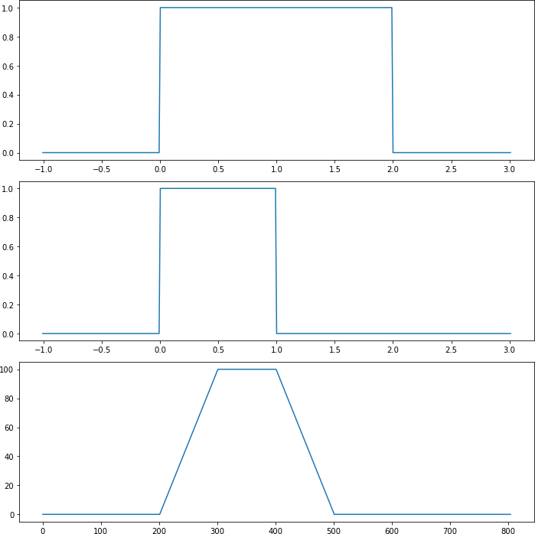

**Question 2:**

a = 29

x1 = np.arange(0,6) x2 = np.arange(0,5)

xn = [a, a-1, a+2, a+3, a+5]

hn = [1,2,3,4]

q = [[29,0,0,0],

[28,29,0,0],

[31,28,29,0],

[32,31,28,29],

[24,32,31,28],

[0,24,32,31],

[0,0,24,32],

[0,0,0,24]]

r = [[1],

[2],

[3],

[4]]

yn = np.dot(q, r)

conv_signal = np.convolve(x_n, h_n)

plt.figure(figsize = (10,10)) plt.subplot(2,2,1) plt.xlabel("n")

plt.ylabel("x [n]")

plt.stem(xn) plt.grid()

plt.subplot(2,2,2) plt.xlabel("n")

plt.ylabel("h [n]") plt.stem(hn) plt.grid()

plt.subplot(2,2,3) plt.xlabel("n")

plt.ylabel("y[n] calculated convolve") plt.stem(yn)

plt.grid()

plt.subplot(2,2,4) plt.xlabel("n")

plt.ylabel("y[n] inbuilt convolve function ") plt.stem(conv_signal)

plt.grid()

# OUTPUT:

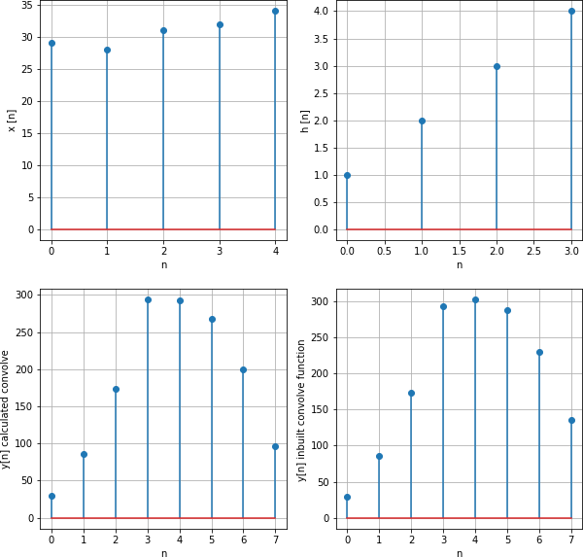

**INFERENCE:**

We have successfully written a code for Convolution of a signal using convolve function from numpy library and also, we have done the convolution for the given signal using matrix method.